UNCOMN Sustainability 2024
UNCOMN has an Environmental Management System (EMS), defined as a five-step process that feeds back into itself, enabling continuous improvement.
UNCOMN’s EMS 5-Step Process to Control Sustainability Issues

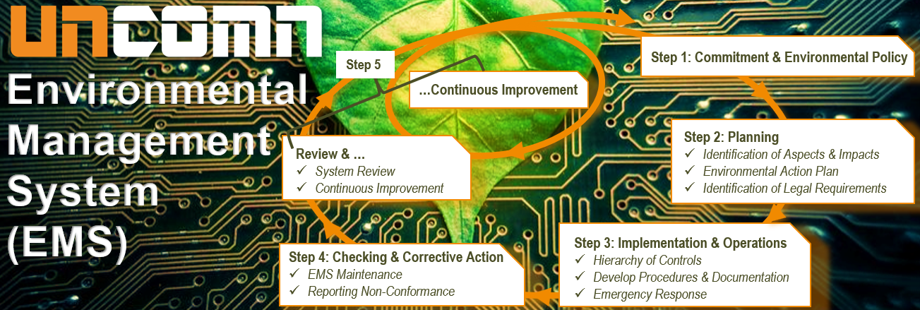
Sustainability Management Policy
The UNCOMN Conservation Management Policy (CMP) is our company-wide “formal sustainability/environmental policy” form. The UNCOMN CMP forms the core element of Step 1 in our EMS. As a formally documented public statement of responsibilities and obligations, the CMP is essential for actualizing the efforts necessary to implement the EMS. UNCOMN partners and senior managers are committed to ensuring acceptance of the CMP as an integral part of operations, and all UNCOMN employees are encouraged to access CMP documentation via our company’s SharePoint site. In the CMP, UNCOMN undertakes the following:
- Establishes an EMS to systematically reduce impact on the environment.
- Prevents pollution related to our activities and operations.
- Conducts operations in compliance with relevant environmental regulations.
- Communicates this policy to employees, business associates, and the wider community.
- Communicates the policy and educate employees on their environmental responsibilities, ensuring it is integrated into their work practices, training, and decision making.
- Continuously improves the environmental performance of our company.

Renewable Energy Sources
As part of Step 2: Planning and Step 3: Implementation & Operations of UNCOMN’s EMS, we identify three avenues for reducing dependency on wasteful energy: (1) partnering with greener energy providers, (2) choosing greener buildings and hardware, and (3) emphasizing green-default cloud solutions and engineering. UNCOMN only works with energy providers like Ameren Corporation that commit to sustainability. By using Ameren’s energy services, we share their Net-Zero Carbon Emission Goal by 2045 and support the following initiatives:
- Invest approximately $7.5 billion in renewable energy over the next two decades
- Build large solar projects like the 200-MW Huck Finn planned to be in service in 2024
- Retire more than 3,500 MW of fossil-fired power generation by the end of 2030
- Incorporate battery storage and other strategies to fill in energy gaps
In our corporate offices, UNCOMN follows the Environmental Action Plan, which identifies physical building systems and hardware solutions that use less energy. We installed next-generation thermostats and other equipment that reduce wasteful energy associated with heating and cooling. By installing light switches with automatic timers, we ensure energy is not wasted in unoccupied rooms.
When spinning up a new project, UNCOMN engineers take full advantage of green-default cloud-based solutions, using containers and container orchestrators like AWS Kubernetes. Containerized applications reduce emission as they typically require fewer servers and have an overall smaller networking and storage infrastructure. Because containerized cloud deployments offer autoscaling and flexibility, they help match our software’s energy use to demand. Whenever possible, UNCOMN proposes and deploys cloud solutions that use only what is needed. As a result, less energy is consumed to power and cool hardware, and existing hardware runs more efficiently.

Recycling Program
As a continuation of Step 3 of our EMS, UNCOMN’s recycling program identifies two types of items for recycling: 1) general office equipment/materials, and 2) specific IT related materials. For the office items, our recycling program focuses on general waste, including paper, plastics, glass, cans, electronics, and potentially organic waste. We begin by performing an initial audit to identify the types and volumes of waste the office generates and then tie this to achievable recycling goals based on the audit’s findings, such as reducing paper waste by a certain percentage or recycling all electronic waste. Below summarizes our office recycling plan.
UNCOMN’s Office Equipment & Materials Recycling Plan
Component | Description
Recycling Bins | - Place clearly labeled recycling bins strategically around the office
Staff Engagement & Training | - Launch awareness campaigns about the recycling program  - Provide regular training on recycling practices and sorting
Recycling | - Work with local recycling services for material collection
Sustainable Office Practices | - Encourage waste reduction practices  - Elect for eco-friendly office supplies and equipment where possible
Monitoring & Reporting | - Track the amount and type of waste recycled  - Regularly review progress towards goals and adapt as needed
Below highlights our recycling efforts that are unique to the IT industry.
UNCOMN’s IT Materials Recycling Plan
Component | Description
E-Waste Collection | - Internal Collection: on-premises areas for e-waste collection (computers, monitors, etc.)  - Sorting: implement system to separate e-waste by type & recycling potential (batteries, cables, devices)
Local  E-recycling Partnerships | - Recyclers: Work with certified e-waste facilities compliant with environmental standards  - Manufacturer Take-Back Programs: Research manufacturer programs offered for responsible recycling or disposal
Data Security Measures | - Data Wiping: Securely wipe all data from devices before recycling  - Certification of Data Destruction: Obtain proof of secure data erasure certificates
Staff Training | - Training Programs: Educate employees on recycling importance and procedures  - Engagement: Encourage participation through communication and incentives
Sustainable Procurement | - Eco-friendly Purchasing: Prioritize eco-friendly, durable, and recyclable IT equipment  - Vendor Assessment: Choose vendors with minimal environmental impact practices/products
Documentation & Reporting | - Tracking: Keep records of amount and type of e-waste collected and recycled  - Reporting: Regularly report on recycling efforts/outcomes to enhance the program

Sustainability Purchasing Guidelines
UNCOMN seeks to adopt sustainability purchasing guidelines for our direct suppliers as part of our EMS by establishing criteria addressing environmental compliance. This ensures our supply chain reflects a commitment to sustainability and mitigates risks. We adhere to the following principles:
- Compliance: We comply with all applicable federal regulations, including the Federal Acquisition Regulation (FAR), in our procurement processes.
- Sustainable Sourcing: When evaluating suppliers, we consider sourcing goods and services from suppliers who demonstrate environmental, social, and ethical responsibility in their operations, including environmental stewardship, social responsibility, and ethical business practices.
- Environmental Impact: We minimize the environmental impact of our procurement activities by considering factors such as energy efficiency, resource conservation, waste, reduction, and carbon emissions throughout the product lifecycle.
- Social Responsibility: We support suppliers who uphold human rights, labor rights, fair labor practices, diversity, inclusion, and safe working conditions for their employees.
- Economic Viability: We seek suppliers who offer competitive pricing, quality products, innovative solutions, and long-term value while maintaining high standards of sustainability and quality.
The below highlights key considerations when purchasing operation materials in a sustainable fashion.
UNCOMN’s Purchasing Guidelines for Sustainability
Guidelines | Actions
Eco-friendly Materials & Processes | - Research and seek out IT and office equipment suppliers that utilize environmentally friendly materials that can be recycled/donated in the future  - Select suppliers that adopt green manufacturing processes to reduce waste
Supplier Evaluation | - Review compliance to our Code of Conduct, including sustainable procurement procedures
Energy Efficiency | - Encourage the use of energy-efficient technologies (e.g., Nest, etc.) and practices (e.g., Cloud-based computing) in the production and delivery of products and services
Waste Management | - Work with IT suppliers that have effective waste management systems, including recycling and safe disposal of hazardous materials
Sustainable Packaging | - Require minimal and recyclable packaging to reduce environmental impact of our suppliers of office and IT equipment where possible
Continuous Improvement | - Regular review and update of our procurement practices to incorporate new sustainability initiatives and best practices

Monitoring Carbon Emissions
Monitoring | During planning phases, our analysis of carbon emissions indicated that our footprint was minimal as a small business IT consultancy. We researched three emissions scopes to measure:
- Scope 1: Direct emissions controlled by UNCOMN (e.g. fuel consumption—heating, workstation equipment, vehicles)
- Scope 2: Indirect emissions associated with energy consumption acquired and consumed by UNCOMN (e.g. lighting, equipment, water heaters)
- Scope 3: Other emissions that UNCOMN can influence but does not control (e.g. business travel, employee commutes in non-company vehicles)
Targets | Despite having a small footprint, we seize this opportunity to make a positive impact, as upstream energy providers account for +80% of our emissions. Therefore, we work with energy providers like Ameren Corporation that have a net-zero carbon plan. We track energy consumption monthly and directly address any deviations from baseline, which we aim to undercut by 15% every year.

Other Ways to Mitigate Environmental Impact Services
UNCOMN employs other strategies to mitigate negative environmental impact, such as investing in the local community’s environmental health. UNCOMN began a two-year Adopt-A-Highway environmental cleanup commitment in 2024 that requires 4 clean ups per year along IL 177/Mascoutah Ave from Schneider Road to Eidemann Road (~1.5 miles). Our cleanups are held in March, June, September, and December. We also commit to a standard recycling program for glass, cans, cardboard boxes, and plastics with the local recycling provider. As noted above, we dispose of IT waste in the proper fashion. As an IT consultancy, aside from energy consumption, the largest source of carbon emissions is end-of-life IT equipment. Therefore, we take special care to ensure these items are recycled properly. We promote a paperless environment with minimal printer availability and adoption of Microsoft 365, particularly tools like Teams and SharePoint, has played a crucial role in this transition and encourages employees to embrace digital alternatives. By leveraging digital collaboration platforms, we have significantly reduced our reliance on paper-based communication and documentation. Reduced energy consumption through move to smaller facilities and shift LEED-certified green buildings.
Implementation of our UNCOMN sustainability policies contribute to global efforts in combating climate change, environmental conservation, and protection of the ecosystem, leading to a healthier environment for present and future generations. Our dedication to renewable energy sources, waste reduction, and greenhouse gas reduction support resource efficiency, improved air quality, and climate stability, reducing the environmental impact and contributing to the conservation of natural resources.

